**Darrian Sampson**

**CSC 406**

**Assignment #1 Schema**

The system design team’s schema simply will not work according to their own desired system characteristics. The design team seeks four things:

1. **The GUI is to finish last, all other threads must end before the GUI does.**
2. **The Word Processor preferably will end first as to make the end user happy.**
3. **The Data Storage Device is to finish before the GUI and is normally slower than the**

**Word Processor.**

1. **Finally, that the Printer can be done with at anytime.**

With the current system that they choose to implement they GUI will fail to end last but instead the Word Processor which is what we want to be the fastest. Off the bat we have the priorities backwards, with this poor design you get the slowest thread as the WP and the fastest as the GUI. Not to mention the Data Storage is finishing after the GUI another con in this priority design.

I on the contrary propose my own design with priority as follows for the threads :

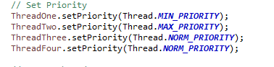

This way the priority corrects the threads. The GUI ends last the WP is second and the DS is done before the GUI.